8/12/2010
Updated and Abridged | Bryce Hanson

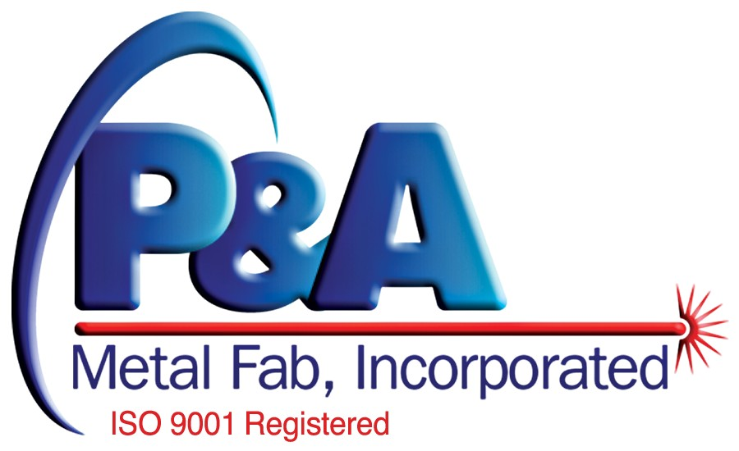
P&A Metal Fab | Strategic Alignment Handbook

Table of Contents
Executive Summary 4
Alignment Process Introduction and Overview 5
PDCA 5
Kaplan and Norton Alignment Process Diagram 7
Step 1: Define Strategy 8
Mission/Values/Vision Statements 8
Mission Statement 8
Values Statement 8
Vision Statement 9
Strategic Analysis 9
PESTEL 10
Porter’s Five Forces 10
SWOT 11
Strategy Formulation 11
Step 2: Plan the Strategy 12
Strategy Map 12
What is a strategy map? 12
What is its purpose? 12
What are the perspectives? 12
Goals and Themes 13
Strategy Map Examples 13
Strategy Map Template 16
Strategy Goals and Measures 17
Example of a balanced scorecard 17
Balanced Scorecard Template 18
Project Portfolio 18
Initiative Prioritization Matrix 18
Theme Teams 19
Step 3: Align the Strategy 20
Performance Linkages 20
Communication Plan 21
Communication Matrix 21
Goals Rollout Form 22
Goals Rollout Form Examples (double click to view) 22
Training Plan 22
Sample Job Description (double click to view): 23
Sample Performance Review (double click to view) 24
Step 4: Plan Operations 25
Major Process Maps 25
Improvement Method Inventory 26
Forecast 26
Resource Survey 26
Step 5: Monitor and Learn 27
Key Performance Indicators 27
Operation Measures 27
Strategic Measures 28
Dashboards 28
Meeting Calendar and Agenda 29
Examples of Meeting Agendas (double click to view) 30
Step 6: Test and Adapt 30
Environmental Scan 31
Adaptation Plan and Measurements 31
Kaplan and Norton Alignment Process Diagram in Detail 32

Strategic Alignment Handbook

Executive Summary
This handbook is designed to aid P&A Metal Fab, Incorporated (P&A) in aligning its strategy throughout the entire organization. It is an adaptation of the alignment process found in The Execution Premium: Linking Strategy to Operations for Competitive Advantage by Robert S. Kaplan and David P. Norton. By using this handbook, P&A will be able to better implement a continuous improvement program for its strategy execution processes.
Many businesses experience performance gaps between higher level strategic planning and their actual day-to-day activities. Businesses that properly align their strategy throughout their organizations experience increased organizational efficiency. This in turn increases the value passed on to stakeholders of the company. The alignment of top level strategy should be of utmost importance to enterprises that want proactively compete in the marketplace. By aligning strategy throughout the organization, a business can maintain a performance premium over its competitors.
Kaplan and Norton have devised a methodology that gives businesses a process to manage their strategic alignment. This process is a six step cycle that produces aligns a company’s strategic plan with its operating plan. The six steps within the process are:
- Define the strategy
- Plan the strategy
- Align the organization
- Plan operations
- Monitor and learn
- Test and adapt
These steps are an iterative cycle that continually refines of the company’s strategic and operational plans. This manual will guide you step by step through the alignment process and will explain how each step relates to one another.

Alignment Process Introduction and Overview
The simplest way to think of executing a business would be to:
- Develop a strategic plan by identifying market opportunities
- Develop an operating plan to implement the strategic plan
- Carry out the operating plan by performing business functions
For some companies, this is as far as it goes. However, market condition changes and competition adjustments over time erode the original effectiveness of a business’s strategy. If P&A expects to continue as a profitable business and avoid being caught off guard by market changes, it must be proactive in improving its strategy and operations.

PDCA
To continuously improve strategy refinement and execution, there should be a system of processes in place to create a closed loop of feedback and adjustment. This is sometimes referred to as Plan-do-check-act (PDCA) or the Deming cycle. This cycle has four steps:

- PLAN
Establish the objectives and processes necessary to deliver the desired results.
- DO
Implement the new processes.
- CHECK
Measure the new processes and compare the results against the expected results.
- ACT
Analyze the discrepancies between expected and actual results to determine their cause.
In Six Sigma programs, the PDCA cycle is called "define, measure, analyze, improve, control" (DMAIC). Whatever the number of elements or preferred nomenclature, the basic process is still the same throughout any continuous improvement program.
For P&A, we will be using the Kaplan and Norton system for strategic alignment. It is a method of continuous improvement that is focused primarily on executing strategy efficiently through the alignment of an organization’s different interests (perspectives). This process has 6 steps that will help to inform the development of the strategic and operating plans of the company previously discussed. These steps are as follows:
- Define the strategy
- Plan the Strategy
- Align the Organization
- Plan Operations
- Monitor and Learn
- Test and Adapt
The following diagram displays the relationship between this strategic alignment process and the simple business planning method mentioned previously.

Kaplan and Norton Alignment Process Diagram
This diagram will be revisited and referred to throughout the manual to help the reader understand the different stages of the alignment process. (For a more detailed diagram Ctrl+click here)

Step 1: Define Strategy
The first step in the alignment process is to define P&A’s strategy. This includes mission, vision, and values statements; strategic analysis; and strategy formulation. The goal of this step is to answer the following three questions:
- What business are we in and why?
- What are the key issues?
- How can we best compete?

Mission/Values/Vision Statements
Execution Premium pg.37:
“Before formulating a strategy, managers need to agree on the company’s purpose (mission), the internal compass that will guide its actions (values), and its aspiration for future results (vision).”

Mission Statement
The mission statement is a brief explanation of the purpose of the company’s existence. It is used to communicate to managers and employees the overall goal they are working towards. The mission statement is usually only 1-2 sentences.
Examples:
“Google's mission is to organize the world's information and make it universally accessible and useful.”
"G.M. is a multinational corporation engaged in socially responsible operations, worldwide. It is dedicated to provide products and services of such quality that our customers will receive superior value while our employees and business partners will share in our success and our stock-holders will receive a sustained superior return on their investment."

Values Statement
The values statement describes the core values of the company. It prescribes the company’s attitude, behavior and character.
Google’s Values are outlined in the “Philosophy” section of their corporate information page. Here is an excerpt:
“As we keep looking towards the future, these core principles guide our actions.
1. Focus on the user and all else will follow.
Since the beginning, we've focused on providing the best user experience possible. Whether we're designing a new Internet browser or a new tweak to the look of the homepage, we take great care to ensure that they will ultimately serve you, rather than our own internal goal or bottom line. Our homepage interface is clear and simple, and pages load instantly. Placement in search results is never sold to anyone, and advertising is not only clearly marked as such, it offers relevant content and is not distracting. And when we build new tools and applications, we believe they should work so well you don't have to consider how they might have been designed differently.
2. It's best to do one thing really, really well.
We do search. With one of the world's largest research groups focused exclusively on solving search problems, we know what we do well, and how we could do it better. Through continued iteration on difficult problems, we've been able to solve complex issues and provide continuous improvements to a service that already makes finding information a fast and seamless experience for millions of people. Our dedication to improving search helps us apply what we've learned to new products, like Gmail and Google Maps. Our hope is to bring the power of search to previously unexplored areas, and to help people access and use even more of the ever-expanding information in their lives.”

Vision Statement
The vision statement describes the desired future state of the enterprise.
Example:
“The goal for Precor is to become the most respected brand in fitness equipment.”
Kaplan and Norton advocate the use of the vision statement as a long term (more than 2 years) goals for the company. The vision statement goals should be separated into 3 different components.
- Stretch Goal
- Definition of Niche
- Time Horizon
Consider this vision statement from Wells Fargo in 1997:
“To have one-million(1. Stretch goal) on-line(2. Definition of niche) customers by the end of the decade(3. Time Horizon)”

Strategic Analysis
After the Mission/Values/Vision statements have been clarified, it is time to gain an understanding of what strategic issues P&A wants to address. To understand the key issues that P&A face, it should conduct a strategic analysis to determine what items need to be address when planning its strategy. The following are several types of analyses that can be conducted to understand the key issues of the business. Treat each of the analyses as tools to systematically brainstorm the issues that define the internal and external environment of the company.

PESTEL
Political/Economic/Social/Technological/Environmental/Legal Analysis.
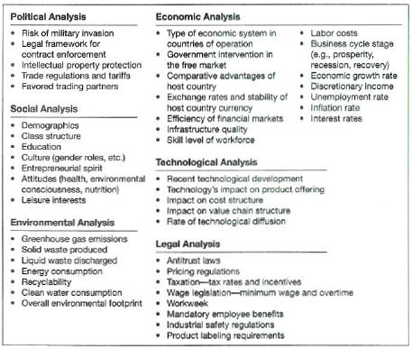

Porter’s Five Forces
- Bargaining power of buyers
- Bargaining power of suppliers
- Availability of Substitutes
- Threat of new entrants
- Industry rivalry

SWOT
Strengths/Weaknesses/Opportunities/Threats analysis.
 | Helpful for achieving the organization’s vision | Harmful for achieving the organizations vision
Internal attributes | Strengths | Weaknesses
External attributes | Opportunities | Threats

Strategy Formulation
Once the management team has conducted the analyses above, they determine what strategic changes need to be made, and why. In formulating a strategy, P&A should determine how they can best compete by addressing these issues:
- In what niches (distinct segments of the market) will we compete?
- What customer value proposition will differentiate us in those niches?
  - Value proposition template:
For (insert customer segment) , P&A Metal Fab, Inc. can offer (insert unique benefit(s) the company can offer) because (insert the company’s unique capabilities in offering the stated benefits) .
- What key processes create the differentiation in the strategy?
- What are the human capital capabilities required by the strategy?
- What are the technology enablers of the strategy?

Step 2: Plan the Strategy
After defining the strategy, P&A must plan how to implement the strategy. Planning a strategy can include the following tools:
- Strategy Map
- Strategy Goals and Measures
- Project Portfolio
- Theme Teams

Strategy Map

What is a strategy map?
A strategy map is a single page diagram outlining the most important strategic goals being pursued by an organization. The strategy map can be likened to a structure in that it shows how each element of a strategy supports the other. Accordingly, the foundational supporting strategies are at the lower end of the map, and the end goals of the strategy are located at the top. The strategy map shows all of the individual elements within a company’s strategy, as well as their relationships with each other. The linkages between each separate element are denoted by arrows. Sometimes the different elements of a strategy are organized as themes.

What is its purpose?
The purpose of having a strategy map is to have a simple diagram that can be relatively easily communicated to anyone in an organization. The strategy map is a passive document that is updated yearly, but it is used as the basis of an organization’s daily activities.

What are the perspectives?
The strategy map is a highly customizable tool, but it usually separates different parts of a company’s strategy into four different “perspectives”:
- Financial
  - Looks at creating long-term shareholder value, and builds from a productivity strategy of improving cost structure and asset utilization and a growth strategy of expanding opportunities and enhancing customer value.
- Customer
  - Includes an organization’s strategy to increase the value passed on to its customers.
- Internal Processes
  - Includes all of an organization’s internal processes that contribute to the accomplishment of its mission.
- Learning and Growth
  - Includes an organization’s strategy for allocating and increasing the value of its human capital, informational capital, and organizational capital.
If you have ever heard of the “balanced scorecard” method, some of this might be familiar, because it was developed by the same people; Robert S. Kaplan and David P. Norton. This is an update of the balanced score card that uses the strategy map as an attractive, but passive document that is then is used to produce “marching orders” for the organization on a daily basis.

Goals and Themes
In each perspective level P&A Metal Fab management will devise several measurable goals which are linked together by themes that flow throughout the Strategy Map. The strategic goals should be Specific and measurable. These goals can be grouped into themes. A theme is an overarching idea that runs through each of the four perspectives. Typically there are several themes in the Strategy Map, which all support the mission, values, and vision statement for the company.

Strategy Map Examples

Generic Strategy Map:
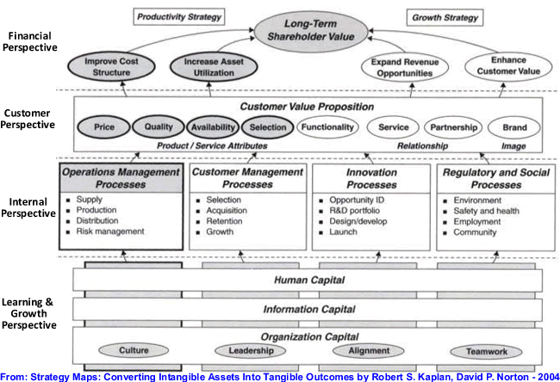

A strategy map doesn’t have to be complicated:
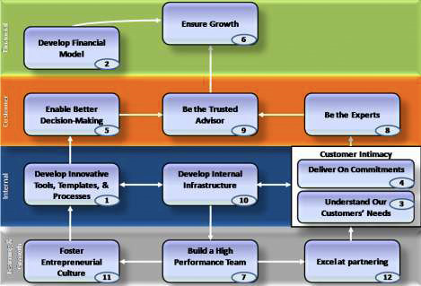

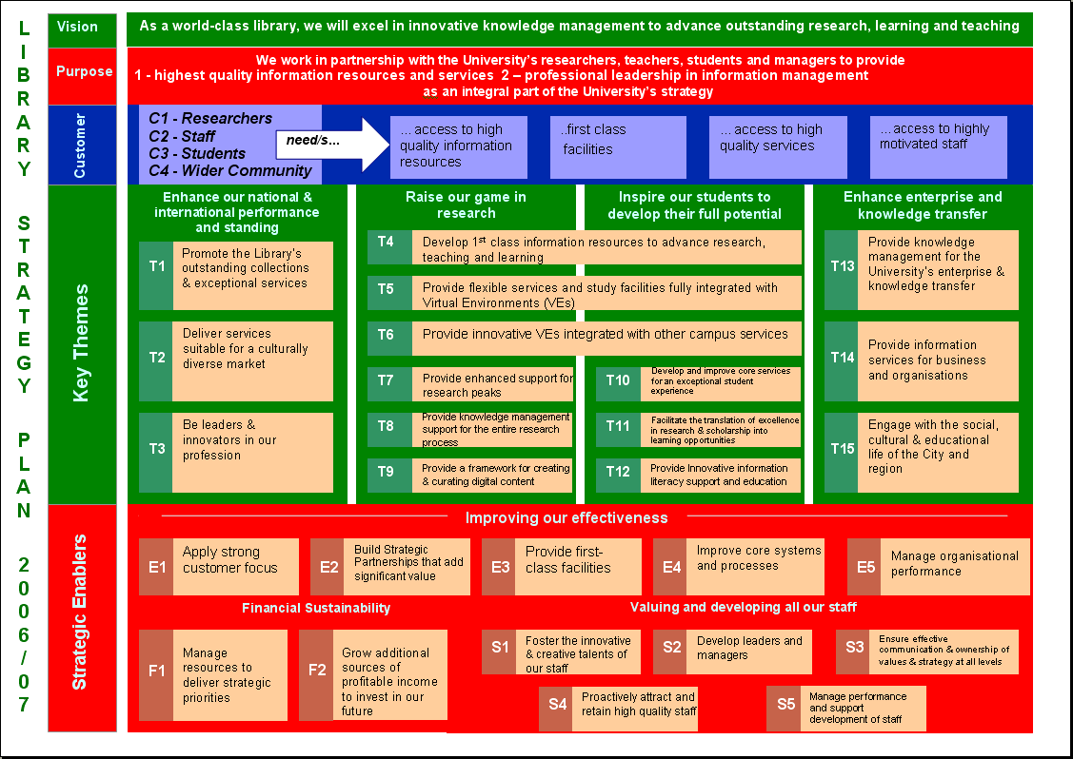
The perspectives are not set in stone. They can be altered to reflect the organization:

Strategy Map Template
Theme 3
Theme 2
Theme 1
Mission
Values
Vision
Financial
Customer
Internal Processes
Learning and Growth
Text | Text | Text

Text | Text | Text

Text | Text | Text

Text | Text | Text

Strategy Goals and Measures
If you can’t measure something, you can’t improve it. Therefore, for each strategic goal, P&A should determine how success will be measured and what the target will be. By determining these measures and targets according to the strategic themes, and organization can create a balanced scorecard.

Example of a balanced scorecard
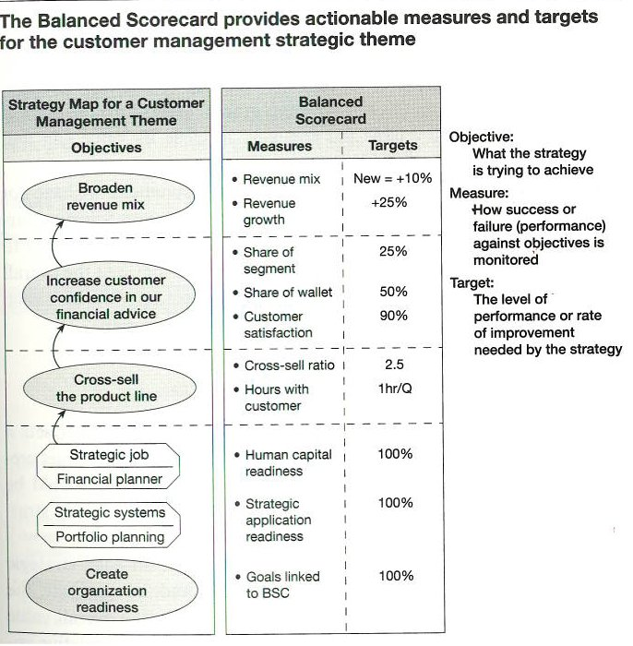

Balanced Scorecard Template
Strategy Map Theme | Balanced Scorecard
Objectives | Measures | Targets
Insert Financial Perspective objective(s) | Insert Specific Measures of the objective | Insert Specific numerical target for improvement in the measurement
Insert Customer Perspective objective(s) | Insert Specific Measures of the objective | Insert Specific numerical target for improvement in the measurement
Insert Internal Process Perspective objective(s) | Insert Specific Measures of the objective | Insert Specific numerical target for improvement in the measurement
Insert Learning and Growth Perspective objective(s) | Insert Specific Measures of the objective | Insert Specific numerical target for improvement in the measurement

Project Portfolio
P&A should maintain a list of projects that would help them in accomplishing the targets set in the balanced scorecard. This list should be prioritized according to how well each of them align with the company’s strategic goals.

Initiative Prioritization Matrix
This imbedded excel spreadsheet can be used to prioritize projects. The white cells are the input for the spreadsheet.
The first part lists the weighting that management gives to each strategic theme. This weighting should show more important themes as having a higher number. This number acts as a multiplier of each projects score in potentially accomplishing each strategic theme.
The second section is where each project is given a score according to how potentially helpful it will be in accomplishing each strategic themes goals. In this template the scoring is from 1-5 with the higher numbers denoting a higher likelihood of accomplishing the theme’s goals.
The final section of the spreadsheet calculates the total weighted for each project using the corporate weighting as a multiplier. You can then rank the projects from top importance (highest weighted score) to lowest importance (lowest weighted score) to the company.

Theme Teams
The purpose of having organizational theme teams within the company is to assign responsibility for projects and/or initiatives taking place within P&A Metal Fab. Through assigning responsibility it makes a point person and their team accountable for the project, tracking project progress, and finally for the achievement of the project. The point person in charge of the theme team does not have to be an expert in the field of the project; however, he/she must be willing to coordinate the project through its completion. Ideally the teams comprised to complete each project/initiative are cross-functional teams and can bring a variety of backgrounds to assist in successfully completing the project/initiative. This process is designed to help P&A Metal Fab be successful in achieving its goals by ensuring that goals, projects, and initiatives are not just talked about, but actualized.

Step 3: Align the Strategy
In this step, P&A must make sure that the all of the employees are aware of the strategy and know their place within it. Alignment is the process of analyzing the cause and effect relationships that effect strategic goals and making adjustments to maximize results.
The accomplishment of P&A’s strategy falls upon the shoulders of the individual employees. Therefore, the strategic vision of the company needs to be understood by all employees. P&A should develop a communication plan for the dissemination of strategic goals and the progress of strategic initiatives. The process of setting goals should focus on cascading from the strategic level down to the operational unit, and then finally to the individual level. This process is made possible through a Goals rollout form that explicitly states how the individual’s or the operational unit’s goals relate to the strategic goals of the company. Finally, an overall training plan should be developed and pursued to increase the capabilities and effectiveness of the employees.

Performance Linkages
This guide’s main purpose is to align the strategic goals of P&A with its operations. However, P&A is made up of several separate operational units. Therefore, P&A must establish a way to address how strategy is integrated across its diverse operating units (sales, production, quality control, etc.). The strategy map is the hypothesis of how P&A creates value; however each theme may not involve every operational unit. Therefore, each operational unit must understand how they specifically affect the value chain of the company. Once this is understood, the operational unit will be better able to make goals that contribute to the goals of the company.
If so desired, each operational unit could construct its own strategy map and balanced scorecard based on those of P&A as a whole. Just like P&A’s strategy map and scorecard, an operating unit’s strategy map should outline the relationships and processes that deliver value, and its scorecard should outline how those processes are measured. (see earlier section on strategy maps and balanced scorecard)

Communication Plan
P&A needs to communicate its strategy to every one of its employees if measured improvement is expected. There is any number of ways that this can be done. In the normal course of business there are emails, phone calls, meetings, and displayed postings that are dealt with everyday. All of these methods can be used to communicate the company strategy. It is helpful to write down how the employees communicate and report to each other. One tool that can be used is a communication matrix.

Communication Matrix
This document ensures that all stakeholders are equally informed of how, when, and why communication will happen. Communication is often a very effective way to solve problems, deal with risks, and ensure that tasks are completed on time.
Successful communication plans will identify stakeholders, the information to be communicated, and how this information will be communicated. They will leave nothing to chance.

Excel Worksheet example (double click to use):
Communication | Purpose | Audience | Frequency | Method | Point of Contact
Example: Project updates | Example: To Monitor and measure the progress of the project | Example: All project participants | Example: First Monday of the month | Example: Email | Example: Bryce Hanson

Word Table Example:

Goals Rollout Form
The purpose of Department and Employee Goals Rollout Forms are to help P&A establish goals that will support their strategy. The templates bellow will help to break down goals into manageable pieces that can be monitored and measured.
The departmental goals would be made by Dan with the help of the respective department manager. The department manager will then be responsible for accomplishing these goals by further breaking them down to the employee level by using the Employee Goals Rollout Form.

Goals Rollout Form Examples (double click to view)

Training Plan
A training plan is used to improve the internal capabilities of the company. Training processes should be determined that focus on improving each of these three areas:
- Knowledge: Understanding gained through education and experience.
- Skill: Knowledge of how to do something consistently in an efficient manner.
- Values: Behaviors, traits, and motivations that people bring to the tasks they perform.
In order to properly plan and monitor the previous three capabilities, there must be a structure to define what is expected of each employee. The following three tools will help to define what is expected of each employee and monitor their performance.
- Job Description: Determine the knowledge, skill level, and values associated with a job and have a written statement of it. This job description should be the basis of measuring performance and determine the training that should be needed.
- Performance Review: Regular one-on-one review and evaluation administered by direct supervisors. Performance should be measured according to the job description. If any deficiencies exist, form a training plan to improve performance.
- Training Plan: Direct supervisors establish training plan for individuals according to what is stated in the job description.
In creating job descriptions, performance reviews, and training plans, consider the following questions:
- What skills do we need to accomplish our strategy?
- What steps do we need to take to increase learning and growth in our company?
- Where are there deficiencies in knowledge and skill levels of our current employees?
- What types of knowledge/skills/values do we most want to cultivate for our strategy?

Sample Job Description (double click to view):

Sample Performance Review (double click to view)

Step 4: Plan Operations
The strategic plan is displayed in the form of a strategy map, which gives a bird’s eye view of how a company delivers value to all of its stakeholders. However, no company can operate from a strategy map; it lacks the detail of operations that need to exist to run a business. The operating plan pertains to the day-to-day operation of the company and gives the detail needed to execute the planned strategy. Essentially, the strategic plan answers the question: “where are we going?” and the operating plan answers the question: “how are we going to get there?”
This may seem complicated, but it’s actually what every business does every day. Every form that gets filled out and every process that P&A does is for the purpose maintaining the business as a going concern. The fourth step of the alignment process seeks to align the operating plan with the strategic plan of the company. Major process maps, improvement method inventories, forecasts, and resource surveys can serve as useful tools in completing this step.

Major Process Maps
In order to outline and understand operations within P&A, a Major Process Maps must be created and maintained. P&A already has many maps of its processes due to the nature of its business. Within the scope of this management system, these maps should be utilized to analyze which processes are critical for implementing the strategy. In the monitoring and learning stage, these maps can also be used to analyze where improvements can be made to the enterprise.

Improvement Method Inventory
The improvement method inventory refers to the continual improvement processes that are being utilized by P&A. Any methods of analyzing processes for the sake of improvement should be documented and followed. LEAN and Six Sigma are examples of some popular improvement methods. This document is similar to the Initiative portfolio, but it focuses on current improvement processes rather than projects.

Forecast
Regularly updated forecasts help to define and plan the operating environment. P&A creates an annual budget in February. This budget is a form of a forecast. The forecast can then be broken down into individual components that will each make up a target goal. Each target should support the goals outlined on the strategy map since it outlines what P&A is trying to achieve. The forecasted targets can then be incorporated into the balanced scorecard so that the progress toward reaching the forecast targets is visually displayed.
A forecast’s usefulness has a short lifespan. A forecast made at the beginning of the year rarely reflects the operating reality towards the end of the year. Therefore, it is advised that P&A use a rolling forecast that updates quarterly.

Resource Survey
A resource survey is used to measure all of the inputs that are used to operate the business. These inputs include: materials, people, skills, time, machinery, capital, etc… While planning, it is important to determine how much of certain resources are required to execute the strategic and operational plans of P&A. If there are resource deficiencies, then P&A must take steps to procure the necessary resources to execute the plan.

Step 5: Monitor and Learn
Once the strategic plan and the operating plan are established, P&A needs to find out whether those plans are actually being integrated into the business.
This is done by measuring and monitoring the operations of the company against the planned goals. The purpose of step five is to gain understanding of how well the company is doing to accomplish its goals.
Key performance indicators, operation measures, strategic measures, and meeting calendars and agendas serve to facilitate this process.

Key Performance Indicators
Key Performance Indicators (KPIs) are established to monitor the main goals of the organization. They should be easily measurable and tied directly to strategic or operating goals. In step two, there was an example of a balanced scorecard. An entire section of the balanced scorecard is devoted to the measures associated with the goals. Therefore, it is important to actually monitor the measures outlined within the scorecard to understand whether progress is being made towards the target.
Strategy Map Theme | Balanced Scorecard
Objectives | Measures | Targets
Insert Financial Perspective objective(s) | Insert Specific Measures of the objective | Insert Specific numerical target for improvement in the measurement
Insert Customer Perspective objective(s) | Insert Specific Measures of the objective | Insert Specific numerical target for improvement in the measurement
Insert Internal Process Perspective objective(s) | Insert Specific Measures of the objective | Insert Specific numerical target for improvement in the measurement
Insert Learning and Growth Perspective objective(s) | Insert Specific Measures of the objective | Insert Specific numerical target for improvement in the measurement

Operation Measures
Examples of operation measures:
- Percent of on time delivery
- Internal rework as a percent of sales
- Number of seconds to accomplish a process.
- Etc…
Notice that each measure can be expressed as a number

Strategic Measures
Examples of strategic measures:
- Number of projects completed
- Customer satisfaction survey results
- Scores on internal assessment tests
Even though these measures are strategic, they should still be expressed as numbers to keep them quantifiable.

Dashboards
One way of keeping track of measurements while communicating them to the employees is through the use of dashboards.
The purpose of a Dashboard is to visually display company targets and the current progress toward reaching each target. These target figures are often derived from budget forecasts. Dashboards are displayed in highly visible areas so that everyone in a specific department or the entire company can see what is trying to be achieved and how close the target is to being reached. Each Dashboard target typically lists the numerical target, current position, percentage complete, and a graph visually displaying the progress.
Dashboards can be updated hourly, daily, or even bi-monthly depending on the nature of the target being measuring. However, it is best to update the Dashboard as frequently as possible to remain current and accurately display progress. Failure to update in a regular fashion may result in loss of relevance with the employees. New targets are set after current targets are accomplished or revised each quarter. See Calendar and Agenda for Dashboard revision dates.
Colors are used to visually indicate how close a target goal is to being achieved. It is important that everyone in the company knows what each color indicates. The following are the standard colors used in Dashboards and their implications:
- Red indicates that little to no progress has been made toward reaching the target.
- Orange through green-tinted-yellow colors indicate that progress has been made toward reaching the target.
- Green indicates the target has been reached.
It also prevents a project from being abandoned by creating transparency. If a target is in the red, management will question those responsible as to what is being done to reach the target, changing the color to green.
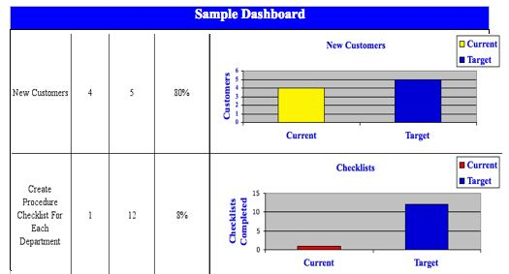

Meeting Calendar and Agenda
Meeting calendars and meeting agendas are used to schedule and plan the various types of meetings that are required to accomplish the alignment process. The following matrix explains three different types of meetings and their purposes. Following the matrix are three sample agendas for each type of meeting.
Meeting type: | Operational Review meetings | Strategy Review Meetings | Strategy Testing and adapting meetings
Purpose: | Are operations under control? | Are we executing our strategy well? (note: not for determining validity of strategy) | Is the strategy working?
Frequency: | At Least Bi-Weekly | Monthly | Yearly
Level: | Departmental, Functional, Financial | Departmental, Functional, Financial | Executive level
Required Information: | - Operations Performance Measures  - Key Performance Indicators  - Dashboards | - Strategy Map  - Initiative Portfolio  - Balanced Scorecard | - Strategy Map (from last planning cycle)  - Balanced Scorecard (from last planning cycle)  - Profitability Reports (i.e. What/Where/How report)  - Analytic Studies (data driven analysis of information)  - External and Competative Analysis (Industry and Market)  - Emergent Strategies (thought leaders

Examples of Meeting Agendas (double click to view)

Step 6: Test and Adapt
The final step in the alignment process is that of testing and adapting. The purpose of this step is to take the lessons learned from step five, and apply them to the next alignment cycle. Step six merges back into step one as the strategy is adjusted and plans are refined.
Re-scanning the competitive environment provides information needed to frame the next iteration of strategy planning.
An adaptation plan is used to determine what adjustments need to be made in the next cycle of the alignment process.

Environmental Scan
An Environmental Scan will help P&A identify the setting in which they operate and help them understand their surroundings. The following steps can be taken to conduct an environmental scan:
- First identify competition and the markets in which P&A competes.
- Create an overview of the exterior forces that are involved with P&A.
- Create a PESTEL and/or SWOT analysis to define the internal strengths and weaknesses and the external opportunities and threats facing P&A. (review the “strategic analysis” section of step one by Ctrl+clicking here)

Adaptation Plan and Measurements
An adaptation plan is essential to continuing the strategy alignment cycle. This is the stage in which the corporate strategy is reevaluated after careful review of the resource survey, the effectiveness of previous initiatives, and the environmental scan. There should be identification of hurdles and issues with the previous cycle that hindered or stalled the implementation of a larger degree of strategy alignment. With these listed and identified, the adaptation plan acts as an audit of the previous cycle of plan-do-check –act. Thus, with this information, the manager is empowered to improve the process in the next cycle, by addressing each issue that occurred previously.

Kaplan and Norton Alignment Process Diagram in Detail

